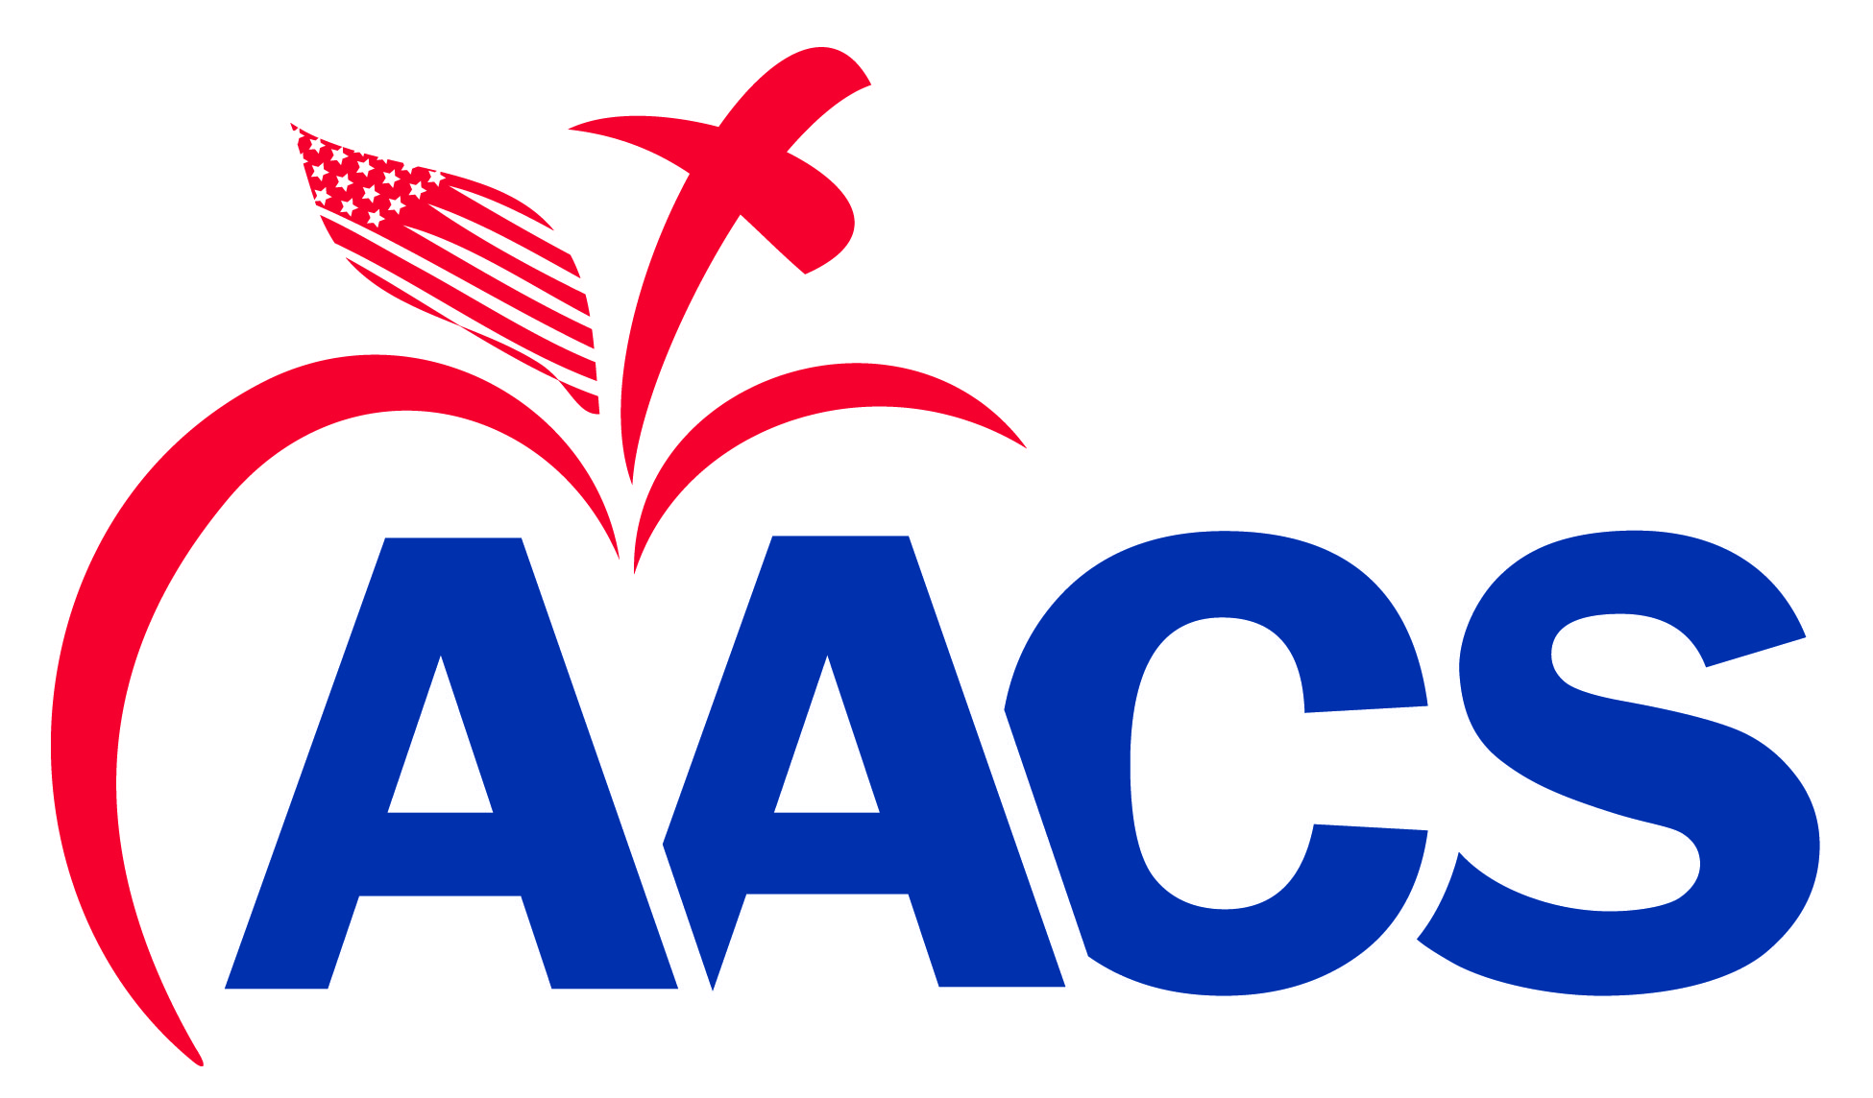
2025 AACS Youth Legislative Training Conference
State Nomination Form

Priority Student Name Home/Cell Phone ( )
# Home Address
Street City State Zip Code
Age Birthday Sex Grad. Year Student’s Email*
Parents Cell Phone ( )
School Name School Phone ( )
School Address
Street City State Zip Code
Principal Pastor
-----------------------------------------------------------------------------------------------------------------------------------------------------
Priority Student Name Home/Cell Phone ( )
# Home Address
Street City State Zip Code
Age Birthday Sex Grad. Year Student’s Email*
Parents Cell Phone ( )
School Name School Phone ( )
School Address
Street City State Zip Code
Principal Pastor
-----------------------------------------------------------------------------------------------------------------------------------------------------
Priority Student Name Home/Cell Phone ( )
# Home Address
Street City State Zip Code
Age Birthday Sex Grad. Year Student’s Email*
Parents Cell Phone ( )
School Name School Phone ( )
School Address
Street City State Zip Code
Principal Pastor

State Associations should email the forms to osummers@aacs.org at the AACS Washington Office by Monday, April 7, 2025.

Please Note: Nomination forms should be sent with the following:
1. A letter of recommendation for each student from his government teacher or administrator
2. A short paragraph written by the student explaining why he desires to attend
*Important: The AACS Washington Office uses the student’s email address as the primary means of communication.
Please provide a usable email address.

